**East Granby Volunteer Fire Department**

**Incorporated 1929**

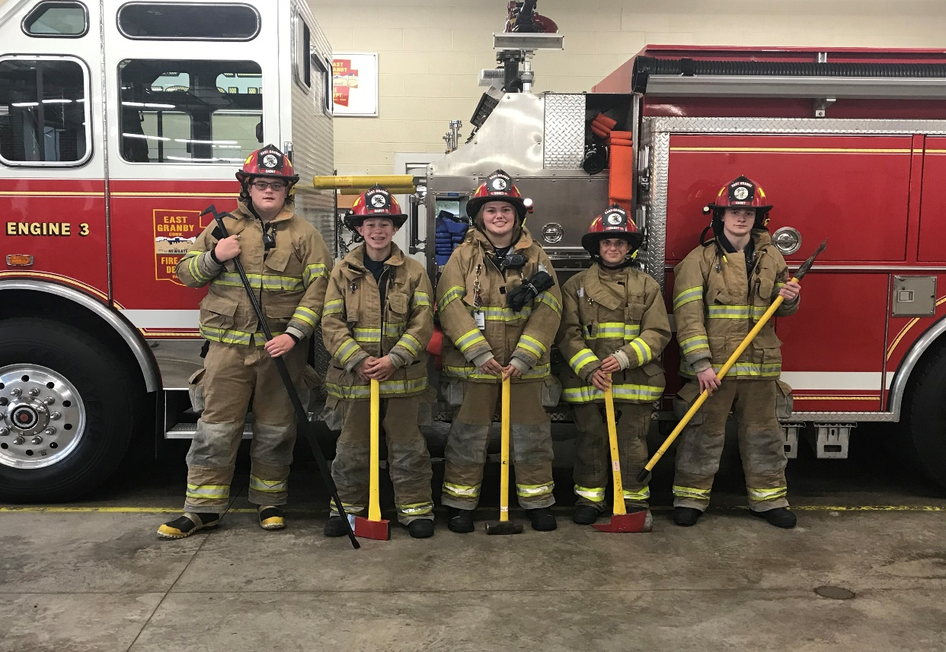

**Cadet Program**

**Policies and Procedures**

*Document Revision 9/1/2019*

**Introduction**

The rules and regulations outlined in this document are for the purpose of advising all members of the East Granby Volunteer Fire Department Cadet Program as to what their duties and obligations as members of the program are. Compliance with these rules and regulations is required and any deviation, under extraordinary circumstances, must be fully justified.

These rules and regulations are not intended to cause hardship or to restrict any member of this program in the effective performance of their duties. The provisions of the rules and regulations are to reflect the high level of integrity, loyalty and dedication expected of our Cadets.

**Policies**

**Drills**

1. All Cadet Drills start promptly at 7pm at the station /location determined by the advisor/instructor. Cadets are expected to be on time for training.
2. All Cadets are to bring full PPE (personal protective equipment) and any training material provided to him or her, to every training exercise unless specified by the advisor or training officer.
3. No Cadet shall enter a station before an advisor, instructor, or member of the East Granby Fire Department is present.
4. Fire stations, equipment, and training materials are to be respected and returned in the order by which they were found.

**Calls**

1. CADET CURFEW POLICY
2. 14 / 15 year olds are allowed to respond to incidents between the hours of 7am to 7pm remaining at the scene no later than 10pm.

16 / 17 year olds are allowed to respond to incidents between the hours of 6am and midnight.

1. Cadets on suspension from the program will be forbidden to respond to incidents/drills/public relations events or be in any fire stations until after the suspension period is concluded.
2. Cadets shall not use any warning devices (i.e. flashing lights, sirens, air horns, etc.) while responding to an incident under any circumstances.
3. Cadets may respond directly to the scene after probationary period and full evaluation of their skills has been formally conducted by the program advisors and respective EGFD officers.
4. Cadets shall **not** drive fire apparatus (*per Town of East Granby insurance policy*)
5. RIDING ON FIRE APPARATUS
6. Cadets must remain seated and seat belted while apparatus is in motion.
7. Cadets will render their spot on any apparatus for a firefighter. If the cadet is ‘bumped’ from the apparatus, the cadet can sign the call sheet but cannot remain at the fire house unsupervised.
8. Cadets shall not enter any hazardous situations (including but not limited to fires, CO calls, hazardous materials incidents, etc.)
9. Upon arrival of any incident, Cadets shall await instruction from an advisor/officer prior to stepping off of the apparatus.
10. Cadets shall not wear Self Contained Breathing Apparatus (SCBA) at any incident.
11. Cadets shall under no circumstances respond to incidents with friends outside of the Fire Cadet Program in the vehicle.

**Activities in which East Granby Fire Department Cadets are allowed to perform based upon state (OSHA / Department of Labor) and local protocol:**

**AGE: 14 / 15 year old**

1. Attend meetings that conclude no later than 10pm throughout the year
2. Respond to incidents no later than 7pm and may remain on-scene no later than 10pm
3. Wear personal protective equipment that readily identifies them as Cadets (i.e. wear the Cadet PPE that is issued to you)
4. Receive instruction and engage in training that does not involve fire, smoke, (except theatrical/latex smoke), toxic or noxious gas, or hazardous materials substances
5. May respond to emergencies on fire department apparatus after receiving proper training (at the age of 15)

**AGE: 16 / 17 year old**

1. Attend and take part in supervised training
2. Wear personal protective equipment that readily identifies them as Cadets (i.e. wear the Cadet PPE that is issued to you)
3. May respond to emergencies on fire department apparatus after receiving proper training
4. Participate in functions within the rehabilitation sector
5. Pick up hose and clean up at the fire scene after the incident commander has declared the area to be safe
6. Fight grass fires, after receiving proper training
7. Perform search and rescue operations, not including structural fire fighting
8. Use pneumatic/power driven saws, shears, Hurst and/or Halmatro Extrication tools, or other power tools during training evolution only
9. Enter the interior of a structure after the fire is extinguished and the structure has been declared safe by the incident commander
10. Set up uncharged attack lines exterior to the structure
11. Change SCBA bottles at emergency scenes
12. Perform traffic control duties after receiving proper training with the exception of Routes 20, 187 & 189
13. Operate pumps, less than 300 gpm at an emergency scene
14. Handle charged hose lines up to 1 ¾” diameter

**The following activities for all Cadets are *prohibited* by state (OSHA / Department of Labor) and local protocols:**

1. Driving any department vehicles in either emergency or non-emergency mode
2. Performing interior fire suppression involving structures, vehicle, or wild land fires, except grass fires
3. Operate a personal vehicle with blue lights
4. Perform firefighting overhaul duties
5. Respond/operate at hazardous materials fires, spills or other events which may expose the Cadet to toxic and/or hazardous materials except for minor motor vehicle gas leaks or spills
6. Perform any activity, except for training performed by qualified personnel (after being medically certified per OSHA 29 CFR 1910.134), involving the use of self-contained breathing apparatus
7. Enter a confined space
8. Perform ‘off-shore’ ice and/or water rescue operations

**CONDUCT**

**Introduction**

Any breach of peace, negligence of duty, misconduct or any conduct on the part of any Cadet which intends to undermine the good order, efficiency or discipline of the program, even though these offences may not be specifically enumerated or laid down, shall be considered conduct unbecoming of a Cadet and subject to disciplinary actions by the advisors of the program.

1. All Cadets shall conduct themselves in a civil and orderly manner at all times. Cadets shall not use profane language or insulting expressions.
2. All Cadets shall meet the general public, employees of the town and citizens of the town with courtesy and considerations. All questions pertaining to department matters and fire calls shall be referred to the Chief, Assistant or Deputy Chiefs of the department.
3. It shall be the duty of every Cadet to promote good public relations by giving assistance when and if it is requested in the course of carrying his/her duties.
4. Any attempt to bring outside influence to bear upon the Cadet Program or Fire Department for whatever purpose or intent, or to avoid the penalties for reprehensible action or conduct shall be considered equivalent to insubordination and treated accordingly.
5. No member of the Cadets shall at any time be insubordinate or disrespectful to a fellow Cadet, superior Cadet Officer, Cadet Advisor or department personnel.
6. No member of the Cadets shall disobey any lawful command or order either verbal or written
7. No member of the Cadets shall maliciously threaten to strike or assault any other Cadet or department member. Cadets who aid or incite any altercation between Cadets or other department members shall be held responsible along with those actually involved.
8. No Cadet shall make any false statement or intentionally misrepresent facts under any circumstance.
9. No member of the Cadets shall intentionally violate federal, state, or local town law or ordinance.
10. No Cadet shall possess and/or drink alcohol, smoke cigarettes, vape, or use illegal drugs at any time while affiliated with the Cadet Program.
11. No Cadet shall discriminate against the citizens of East Granby, members of the department or other Cadets due to age, color, disability, ethnicity, national origin, political affiliation, race, religion, gender or sexual orientation.
12. Harassment of any kind will not be tolerated by the Program and shall be reported immediately to an advisor (outlined in the harassment policy)
13. Any Cadet involvement with law enforcement for adverse reasons shall report the incident immediately to the Chief of the department or advisor(s) of the program.

**Inappropriate Behavior**

* Unlawful behavior, noisy or quarrelsome conduct, lewd or indecent activity
* Possession of a fire arm or other deadly weapon
* Threats or acts of physical violence against members of the public, department, town employees, or other Cadets
* Sexual activity to include possession or use of printed or audiovisual material that is sexually offensive
* Abusive behavior, hazing or harassment
* Alterations or modifications of vehicles, apparatus, buildings, computers, or items of equipment owned or operated by the department without the Fire Chief’s authorization
* Publicly criticizing the official actions or orders of a superior officer. Nor may a member of the Cadets publicly speak disrespectfully of the program, department, or its members
* Making a false statement in any official communication or in conversation with another member or citizen
* Performing any act or making a statement oral or written about one’s immediate officer or fellow Cadets intending to destroy morale, good order, or working relationship with coworkers
* Displaying insolence or indifference, evading or not following direct order from an officer during an emergency incident

**Disciplinary Action**

Disciplinary action is a tool to allow advisors and company officer to deal effectively with Cadets whose performance or conduct is unacceptable.

Disciplinary actions are taken to promote the efficiency of program operations. In exercising discipline, the program with due regard to each Cadets legal rights will ensure disciplinary actions are based on objective consideration without regard to age, color, disability, ethnicity, national origin, political affiliation, race, religion, gender, sexual orientation, or other non-merit factors.

If a member of the Cadet program has violated a program rule, regulation, procedure or policy, the following procedures may apply:

1. Documented verbal reprimand
2. Two (2) filed written reprimand
3. Suspension from the program and / or activity
4. Expulsion / termination of membership

If the offence is in a serious nature when the above steps cannot be taken, the Cadet’s termination will be reviewed by the administrative staff of the program. During this review, the Cadet will be suspended from all Cadet activities.

For each action taken, a letter will be given to the Cadet which their parent/guardian will have to sign. The Cadet will have to bring the letter with them to the next drill they are allowed to attend. If the letter is not signed, the Cadet will not be allowed to attend drills or respond to calls until the letter has been returned to the advisor or Chief of the department.

**OPERATIONS**

**Fire Ground Dress / Response – PPE Usage / Care**

It is the intent of the East Granby Volunteer Fire Department Cadet Program to ensure the safety of all Cadets by having them properly outfitted with personal protective clothing.

**All Cadets at emergency scenes will wear personal protective equipment as issued by the department**

In general, protective clothing shall include (but not limited to) turn out coat, bunker pants, gloves, helmet, boots, hoods, protective eye gear, and DOT safety vests.

Gear may be removed upon direction of the incident commander or Cadet Advisor for other purposes.

**Leave / Sickness / Injury**

It shall be the duty of each Cadet to attend training / drill sessions but will be excused for the following reasons: academic commitments, sickness or death in the family, personal sickness, or vacation. Each Cadet shall notify their advisor or Cadet Captain that they are unable to attend the training / drill session prior.

1. All Cadets of the program are required to report in writing, any changes in their residence, telephone number, emergency contact name/number or any change that would affect their personal information as soon as possible after such change.
2. Any Cadet injured while performing in a drill, incident, or on fire department property must notify an advisor / fire officer at the time of occurrence. An injury report form must be filled out at the time of the incident.

**Leave**

A member is granted a leave of absence for personal reasons is excused from attending drills and calls for the period of his or her leave request. The Cadet must notify in writing to his or her advisor. Personal leave shall consist of any amount of time not to exceed six calendar months.

**Injury**

Any member of the Cadet program who has been absent from duty for a medical condition, injury, or any other reason that may affect his/her performance may not return to duty until certified fit for duty through a physician’s note.

**Resignation from Program**

Notice of resignation shall be in writing and shall be delivered to the Cadet advisor.

A resigning Cadet shall turn in any and all property issued by the fire department within one week. A Cadet may be assessed a replacement cost for any item that is not returned or is returned damaged or destroyed.

**Lost / Damaged Equipment**

This standard sets forth the requirement for reporting lost, damaged or destruction of equipment owned or operated by the department or Cadet program.

On discovery that a piece of equipment has been lost, damaged or destroyed, a Cadet shall immediately report his or her findings to the Cadet advisor or fire officer.

It is the responsibility of every Cadet to properly use and maintain all equipment assigned to him or her.

The deliberate or willful misuse, theft, loss, damage, or destruction of any tool, equipment or other device owned by the department, program, or other agency or private individual will result in appropriate disciplinary action.

As part of the disciplinary process, the individual(s) responsible for the loss or destruction may be required to reimburse the program or department for the cost of the repair or replacement of the equipment.

**Uniform Usage Policies**

The following indicates the proper EGFD Cadet attire to be worn for the following occasions:

Parades / Formal Functions / Fundraisers

1. Department Issued Class A uniform to include:
   1. Long Sleeve dress shirt
   2. Navy Pants
   3. Bell Cap
2. Black leather belt silver buckle
3. Black shoes clean / Short boot type
4. Hardware to include
   1. Bell Cap Pin
   2. Name Tag w/serving since date
   3. Tie Clip
   4. Cadet Badge

Please report any uniform issues to your advisor.

**Radio Procedures**

This standard establishes guidelines for the use of two-way radio communications equipment. It is designed to promote the most efficient and effective use of radio communication system.

The radio system is designed for emergency communications. Therefore a number of subjects are inappropriate when using the system. Common sense and good judgement should always be the user’s guide when deciding the appropriateness of a message.

Personnel who use a two-way radio should realize the radio does not afford the user the same level of privacy as when making a phone call.

The following items are inappropriate and should never be broadcast over a two-way radio:

* Any term that would be offensive to someone of another race or gender
* Profanity
* Arguments or sarcastic remarks
* Any discussion of an athletic event or political contest
* The name of a deceased firefighter or civilian
* Business of a personal nature

**East Granby Volunteer Fire Department Cadet Division**

**Title:** Fire Cadet Captain

**Reports to:** Cadet Advisor

1. Captain supervises and is responsible for each Cadet assigned to the program
2. Captain shall be responsible for the following:
   1. Preparing reports and maintaining records as required
   2. Assists Cadet advisor in preparing drills
   3. Obeying, supporting and enforcing the program rules, regulations, policies and procedures and requiring the same of the Cadets
   4. Setting a good example for Cadets and requiring subordinates to meet all required standards of conduct and performance
   5. Promptly reporting in writing any violation of the program rules, regulations, policies and procedures to the Cadet advisors
   6. Performing other such duties as may be required

**East Granby Volunteer Fire Department Cadet School Policies**

Pagers in school

Cadets must keep pagers off while in school or participating in after school activities as to not create a disruption. Cadets must follow school guidelines relative to cell phones, tablets, and other electronic devices.

School Requirements

1. Cadets suspended from school are suspended from attending drills, going on calls, public relations events, or being in any fire station for one week or the duration of the suspension depending on which is longer. You are to inform the Cadet advisor if you have been suspended. A failure to do so will result in a longer suspension form the program to be determined by the Cadet advisor and Fire Chief.
2. Cadets receiving detention will not be allowed to attend drill for that week nor will they go to calls on the day of the detention. You are to advise your Captain if you have received a detention. Failure to do so will result in a one-week suspension.
3. The advisors will check grades from time to time as well as attendance and behavior in school with the school administration.

**School First, then Fire Cadet Program!!**